


Direct-write Print Deposition of Silica Nanospheres

Prepared by:
Danielle “Elle” Clarke

Faculty Advisors:
Dr. Jon Kellar
D. W. Fuerstenau Professor, Department of Materials and Metallurgical Engineering

Dr. William Cross
Associate Professor, Department of Materials and Metallurgical Engineering

Dr. Alfred Boysen
Professor, Department of Humanities

Program Information:
National Science Foundation
REU Site Award #1157074

Research Experience for Undergraduates
Summer 2012

South Dakota School of Mines and Technology
501 E. Saint Joseph Street
Rapid City, SD 57701
Table of Contents
Abstract .......................................................................................................................................... 3
Introduction .................................................................................................................................... 4
Background ........................................................................................................................ 4
Objectives .......................................................................................................................... 5
Broader Impact .............................................................................................................................. 6
Experimental .................................................................................................................................. 7
Materials ............................................................................................................................ 7
Equipment .......................................................................................................................... 7
Procedure............................................................................................................................ 8
Results ......................................................................................................................................... 12
Initial Direct-Write Printing ............................................................................................ 12
Initial Dip Coat ................................................................................................................ 14
Mixed Solvent Dip Coat .................................................................................................. 16
Direct-Write Ethanol ....................................................................................................... 17
Direct-Write Formamide ................................................................................................. 18
Contact Angle .................................................................................................................. 19
Surface Tension ............................................................................................................... 20
Discussion ................................................................................................................................... 20
Conclusions ................................................................................................................................. 22
Recommendations and Future Work ............................................................................... 23
References ................................................................................................................................... 24
Acknowledgements ..................................................................................................................... 26
Abstract
Ordered nanoparticle monolayers can be used to create a print mask in order to aid in the deposition of ordered arrays of other nanomaterials. Such deposition is already being done with monolayers prepared by dip coating and similar specialized methods. Direct-printing was investigated as an alternative to these other methods as direct-write printing is potentially more amenable to industrial-scale production. The eventual application of these mask layers is for use in photovoltaic cells. This research is not conclusive in direct-write printing of monolayers, but forms the groundwork for further investigation and research. It was found that the regions with the best monolayer coverage have a slight green coloration the wavelength of which correlates to the particle diameter. It was also found that unmodified silica colloid solution shows the coffee-ring effect more so than solutions mixed with other solvents. Additionally, in the portions used experimental glycerol was ruled out a solvent because under ambient conditions the solvent failed to evaporate even with extended time.

Introduction
Background
The goal of this research is to deposit a highly ordered layer of nanoparticles using direct-write print techniques. These particle monolayers create a nanoscale lithography mask—similar in concept to stencils for use with paint. These particles are deposited in a highly ordered structure—the mask—and then a different material is deposited on top of the surface layer. Where there is no coverage by nanoparticles (the spacing between the particles, shown in black in Figure 1) the second material will deposit directly onto the original surface. With the removal of the nanoparticle layer a fixed array of the second material remains deposited on the surface. The type and size of nanoparticles are variable depending on the exact conditions for research but, the solution should have uniformly-sized particles to achieve the best quality packing. Solvent composition can be varied with some ease; however, the ability of the solvent to evaporate under ambient temperature conditions and safety hazards of the solution should be considered to improve the drying process and setup. Because the silica nanospheres under investigation in this research are already suspended in water, any other solvents to be added should be fully miscible with water.
This is a bottom-up method, meaning that the highly-ordered monolayer stems from self-assembly. Self-assembly originates from the flow within the solution as solvent evaporates, causing the movement of particles into ordered arrangements. As the flow ceases with the complete evaporation of solvent, the particles are deposited onto the surface in a particular arrangement.^{1, 3, 4, 9, 11} Ideally, these particles will assemble with hexagonal (2D) packing, and therefore, minimal spacing between the spheres. In Figure 1, the particles are shown as white spheres against a dark background. The triangle shown in red is definitive of the desired structure and differentiates it from other close-packed structures. The name arises from the hexagonal shape of the particles around a central sphere and this shape is shown in gray.
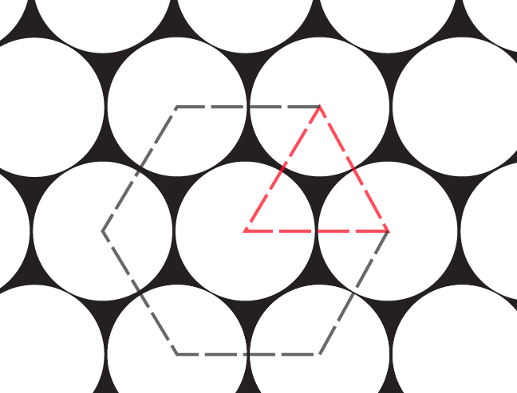
Figure 1. Diagram illustrating the hexagonal packing structure.
Objectives
These close-packed monolayers have already been achieved by other specialized methods, such as dip coating and spin coating with similar nanoparticle solutions. What is being investigated is if similar results can be achieved via direct-write printing of the colloidal solution. Less research has been performed for deposition using print techniques as opposed to these other more specialized techniques.^{13, 16} The goal is to simplify and automate this process while still achieving high quality coatings. The coating will need to be of adequate quality to function as a mask. Also, the method for obtaining these layers should be more reproducible, simpler, or able to coat larger areas than the specialized methods mentioned previously for this method to be useful.

Broader Impact
This technology is part of a larger project to create plasmonic photovoltaic cells in collaboration with other South Dakota universities. This overall project is far broader than the scope of this project alone. The exploration of direct-write techniques stems from a desire to create a more efficient method for creating highly ordered monolayers for mask purposes. With the application of this layer, ultimately gold nanostructures can be written on the surface in a regular, ordered array. The nanoparticle mask can be removed and the gold nanopillars are left in an ordered array. Specialized nanoparticles are mounted on the gold nanostructures, which are used in the cell to upconvert energy from near-IR radiation. The use of the silica nanospheres as a lithographic mask is to reduce the waste in achieving ideal structuring of materials that are more expensive.¹⁰
The direct-write technology under primary investigation is ultrasonic spray coating, namely the Sono-Tek Exacta Coat. This system is similar in concept to a paint sprayer (although the exact mechanisms do vary) and because this process is automated it is highly reproducible.
The spray coating method consumes a considerable amount of solution in comparison to a method such as dip coating (at least in a research scale and before optimizing the procedure); however, if successful this method can be applied at an industrial scale. The immediate goal for the use of this material is in photovoltaic cells, and this process would allow these cells to be produced at a larger scale. For the creation of these plasmonic photovoltaics, many specialized parts are required, by finding ways to scale each of these to an industrial scale the entire process could be commercialized and eventually made readily available to the public. This use makes this part of green technology to create assessable sources of renewable energy.

Experimental
Materials
- ~5 wt% silica, SiO₂, nanoparticles (~500 nm particle size) suspended in water
Preparation by South Dakota State University by the Stöber process—the generation of monodisperse silica particles from alkoxysilanes¹⁵
- Isopropyl Alcohol, (CH₃)₂CHOH
Substrates:
- Laboratory glass slides (standard 1” x 3” size)
- Kapton®, Polyimide Film
- Silicon wafers
Solvents:
- Ethanol, CH₃CH₂OH
- Glycerol, C₃H₈O₃
- Formamide, HCONH₂

Equipment
Inverted Optical Microscope, Nikon Epiphot 200
Scanning Electron Microscope, Zeiss Supra 40 VP field emission SEM
Contact Angle Goniometer, Ramé-Hart Model 500 with DROPimage software
Sono-Tek ExactaCoat with Impact EDGE™ print head (Pictured in Figure 2)

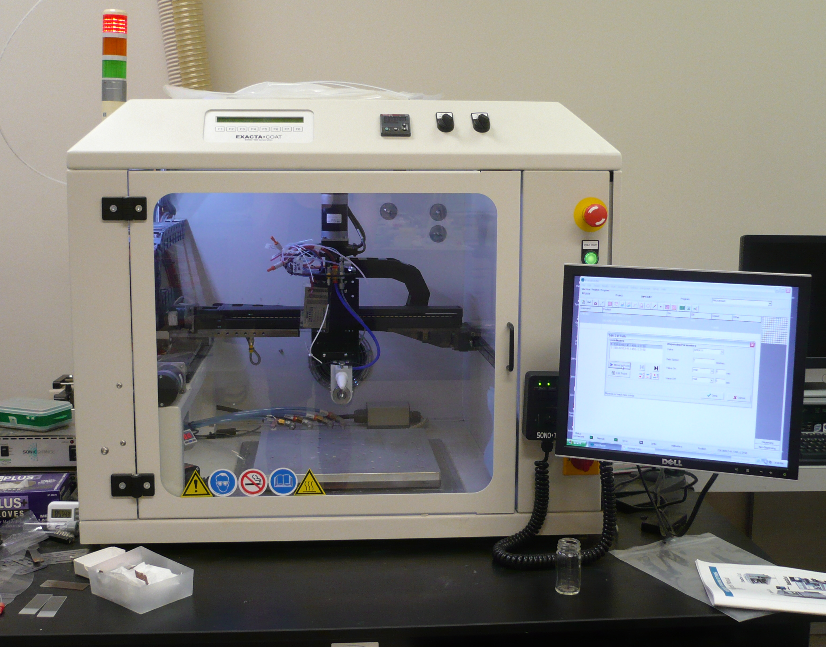
Figure 2. The Sono-Tek ExactaCoat, a fully-programmable precision ultrasonic spray coater.
The print head in use with the ExactaCoat is the Impact EDGE™, this nozzle uses a controlled jet of air to deflect the spray and create a fan shaped pattern. There are two basic parts in this: the ultrasonic nozzle and a flat jet air deflector. The ultrasonic nozzle atomizes the solution, which the jet of air then shapes into a fan spray.⁵

Procedure
Prior to any deposition, the substrate surfaces were cleaned with isopropyl alcohol and dried. During the initial period of research printing on both glass and Kapton® was performed; however, as the research progressed the decision was made to emphasize printing on glass over focusing on multiple surfaces.

Direct-Write Printing:
Direct-write printing of the samples was performed using the Sono-Tek ExactaCoat system as the means of sample deposition onto the surface. Because of the nature of this instrument the substrates (glass and Kapton®) were coated in the same fashion, the only adjustment that may be necessary is the programmed path length. For example, large pieces of Kapton® require a larger area to be sprayed then a small glass slide. The ExactaCoat is equipped with a vacuum on the plate of the instrument to hold the sample flat. The vacuum was only used for Kapton® films. This difference is not assumed to significantly affect the outcome of the printing.
A printing program was established in order to follow the same procedure for all trials. The head is positioned first at a single point were it sprays to discharge excess build up on the print head. The head moves into a position forward of the sample where it sprays several seconds to establish a constant flow and then moves backward over the sample in a single straight pass. The path length is adjusted based on the sample dimensions. The variables for printing consist of: infusion rate, print head height, path speed, and sonicator wattage (related to the droplet size).
The nanoparticle solution is pumped through the tubing using a syringe loaded with solution. This process is controlled by the computer system and therefore the infusion rate can be carefully adjusted. The bulk solution reservoir and the internal tubing are kept sealed from the atmosphere and the solution is only exposed at the nozzle. The purposes of establishing spray before starting to coat the sample include eliminating any buildup on the nozzle (where the solution is exposed to air) and establishing a constant flow.

Dip Coating:
Dip coating was achieved by evenly drawing glass slides out of the colloidal silica solution. The Sono-Tek ExactaCoat was modified to draw the slide from the solution with a controlled withdrawal speed. This was ideal because it meant that the withdrawal speed could be precisely controlled along with the path length (and thusly, total displacement).

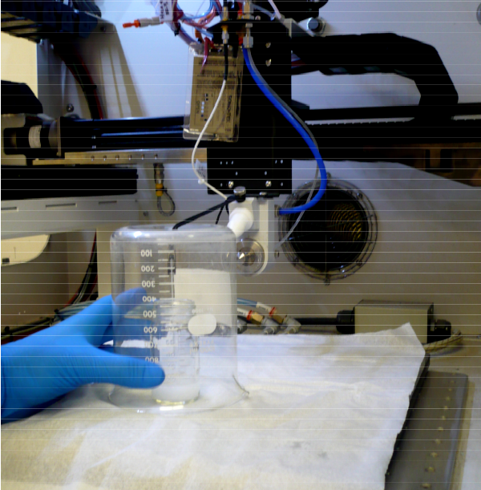
Reservoir of silica solution
Figure 3. ExactaCoat adjusted to regulate the withdrawal speed for dip coating.
The implemented program translated the print head directly back from the beaker a set distance in order to pull the slide out of the solution. The red arrows illustrate the translation of the direction of movement. In this image and for any positioning of the apparatus the head is at its furthest point back and the slide remains above the solution surface.
The modifications to the system consisted of a string attached above the print head while the other end of the string held the glass slide in the colloidal silica solution. The ExactaCoat was programmed to move back approximately 15 cm at a specified velocity. The string is pulled through a support (a 1000 mL beaker with a small hole in the base) causing an approximate 90° change in angle, translating the x-axis movement to lifting the slide in the z-axis (this movement is shown by red arrows in Figure 3). The solution and the slides are positioned while the head is positioned furthest backwards, as is shown above. Once the apparatus is positioned, the head is directed into the starting position (submerging the substrate) and then the head moves backward to withdraw the sample at an established speed.

Mixed Solvents:
After the initial dip coating results on glass the effects of solvents with varied boiling points compared to water were investigated. Mr. Kelsey Fitzgerald, my research partner, prepared solutions of 50% silica colloid and 50% of a miscible solvent, by volume. Ethanol (78.37 °C) was used to create a low boiling point solution. Glycerol (290 °C) and formamide (210 °C) were used to prepare higher boiling point solutions. With these solutions, dip coating and direct-write printing were repeated under the same procedures as described in the above sections.

Contact Angle and Surface Tension:
Using the contact angle goniometer, the contact angle of the solution can be measured by sessile drop on the varied substrates under investigation. The contact angle measurements are recorded in sets of ten measurements over ten seconds. Using the same instrumentation, the surface tension of the solutions can be determined using a pendant drop method. Surface tension follows a different procedure and trials consist of 40 measurements in an individual series over approximately four seconds.

Results
Initial Direct-Write Printing
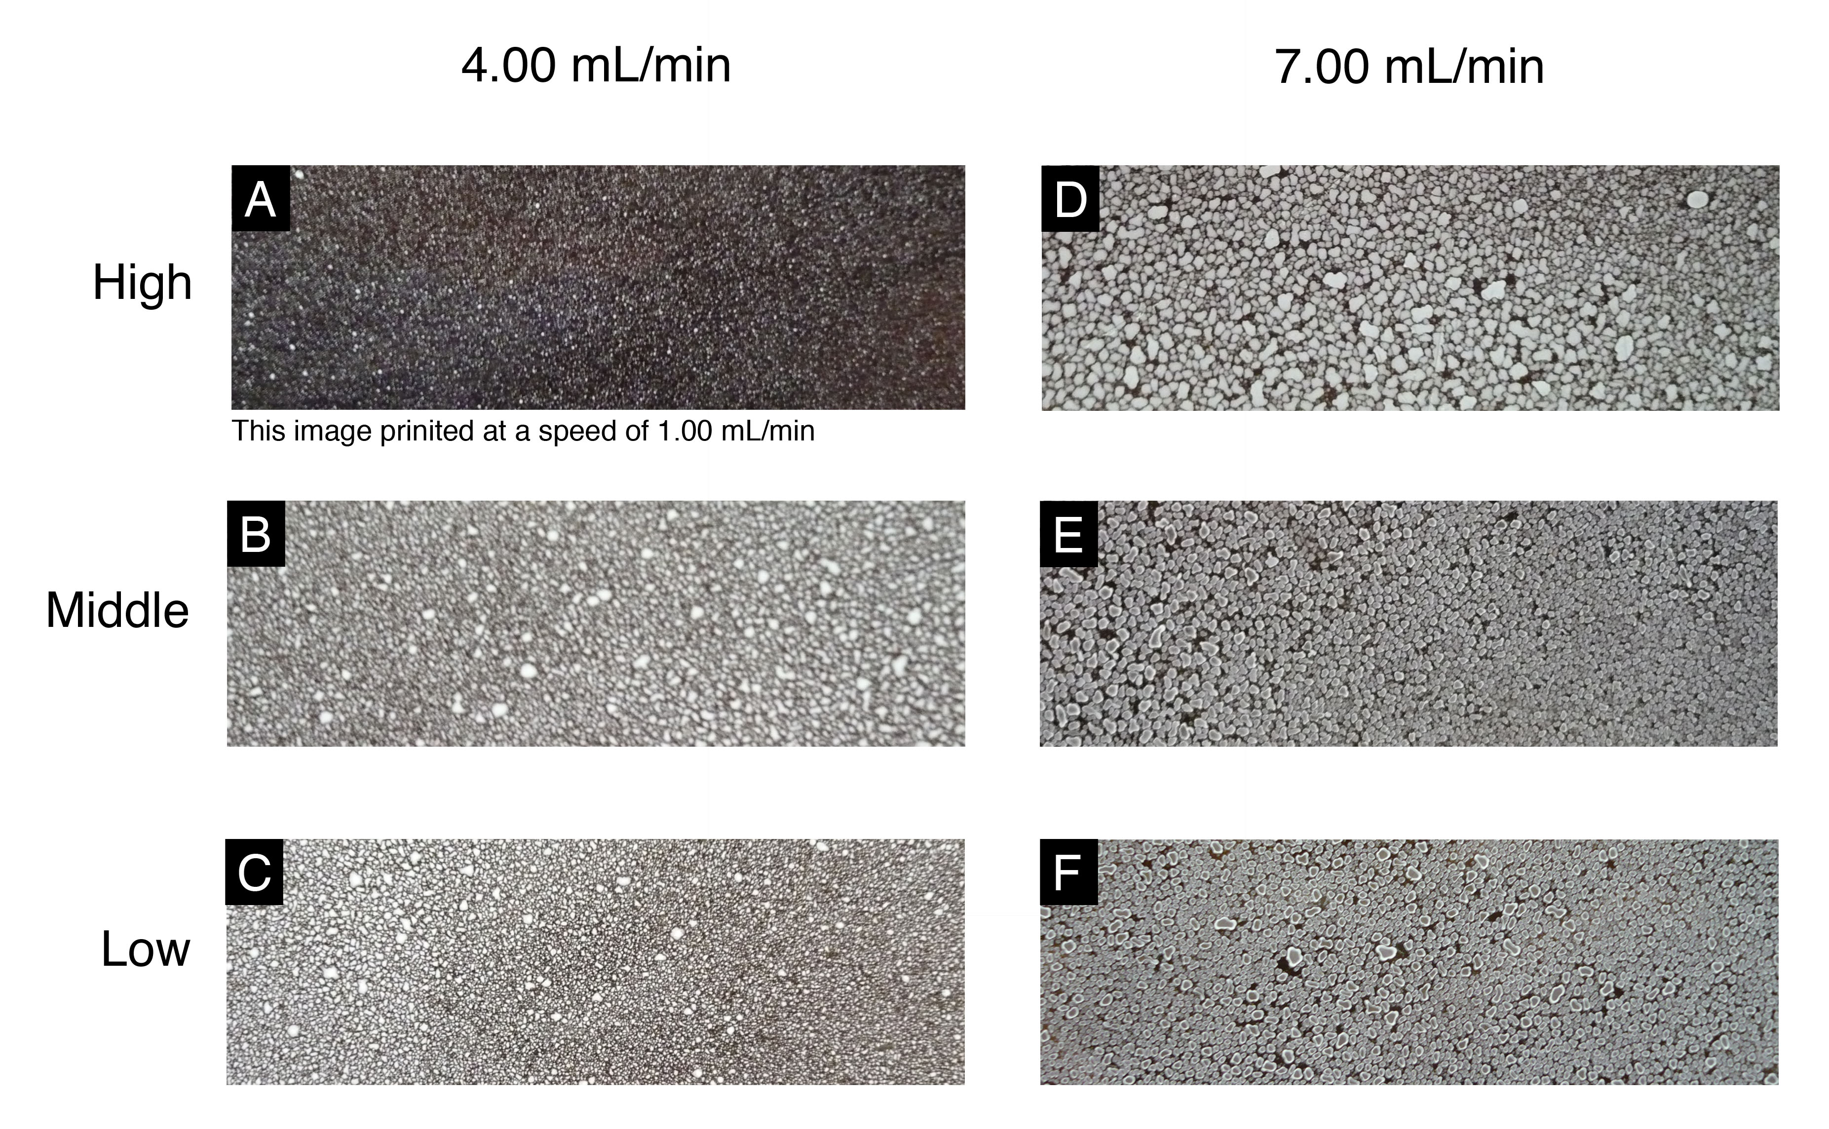
Figure 4. Photo images of the initial print tests on Kapton® film. Parameters varied are solution infusion rate and print head height all other parameters were maintained constant between runs.
Several sample flow rates were investigated at three heights. Although the given designations “high,” “middle,” and “low” these are replicable, but arbitrary, coordinate points. The path speed was maintained at 50 mm/sec for all samples. Similar print conditions were also used for printing onto glass and are detailed below. After this point printing on Kapton® was not further pursued and the focus was shifted to using glass slides as the substrate.
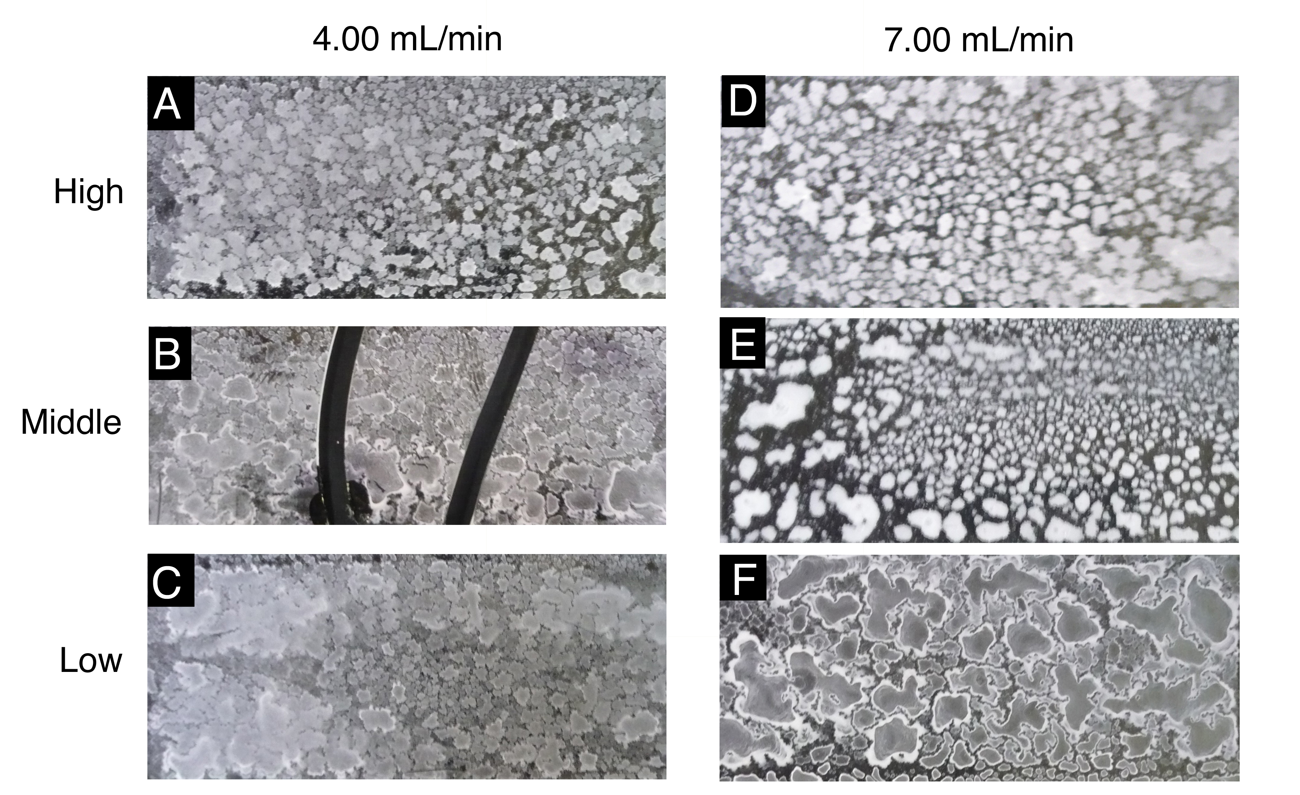
Figure 5. Photo images of the initial print tests of silica on glass slides.
All six samples were with the exception of the lower right were prepared on the same day. Slide B was cracked after taking SEM images from the sample, hence the dark stripes in the image, which are actually gaps between the fragments of the slide.
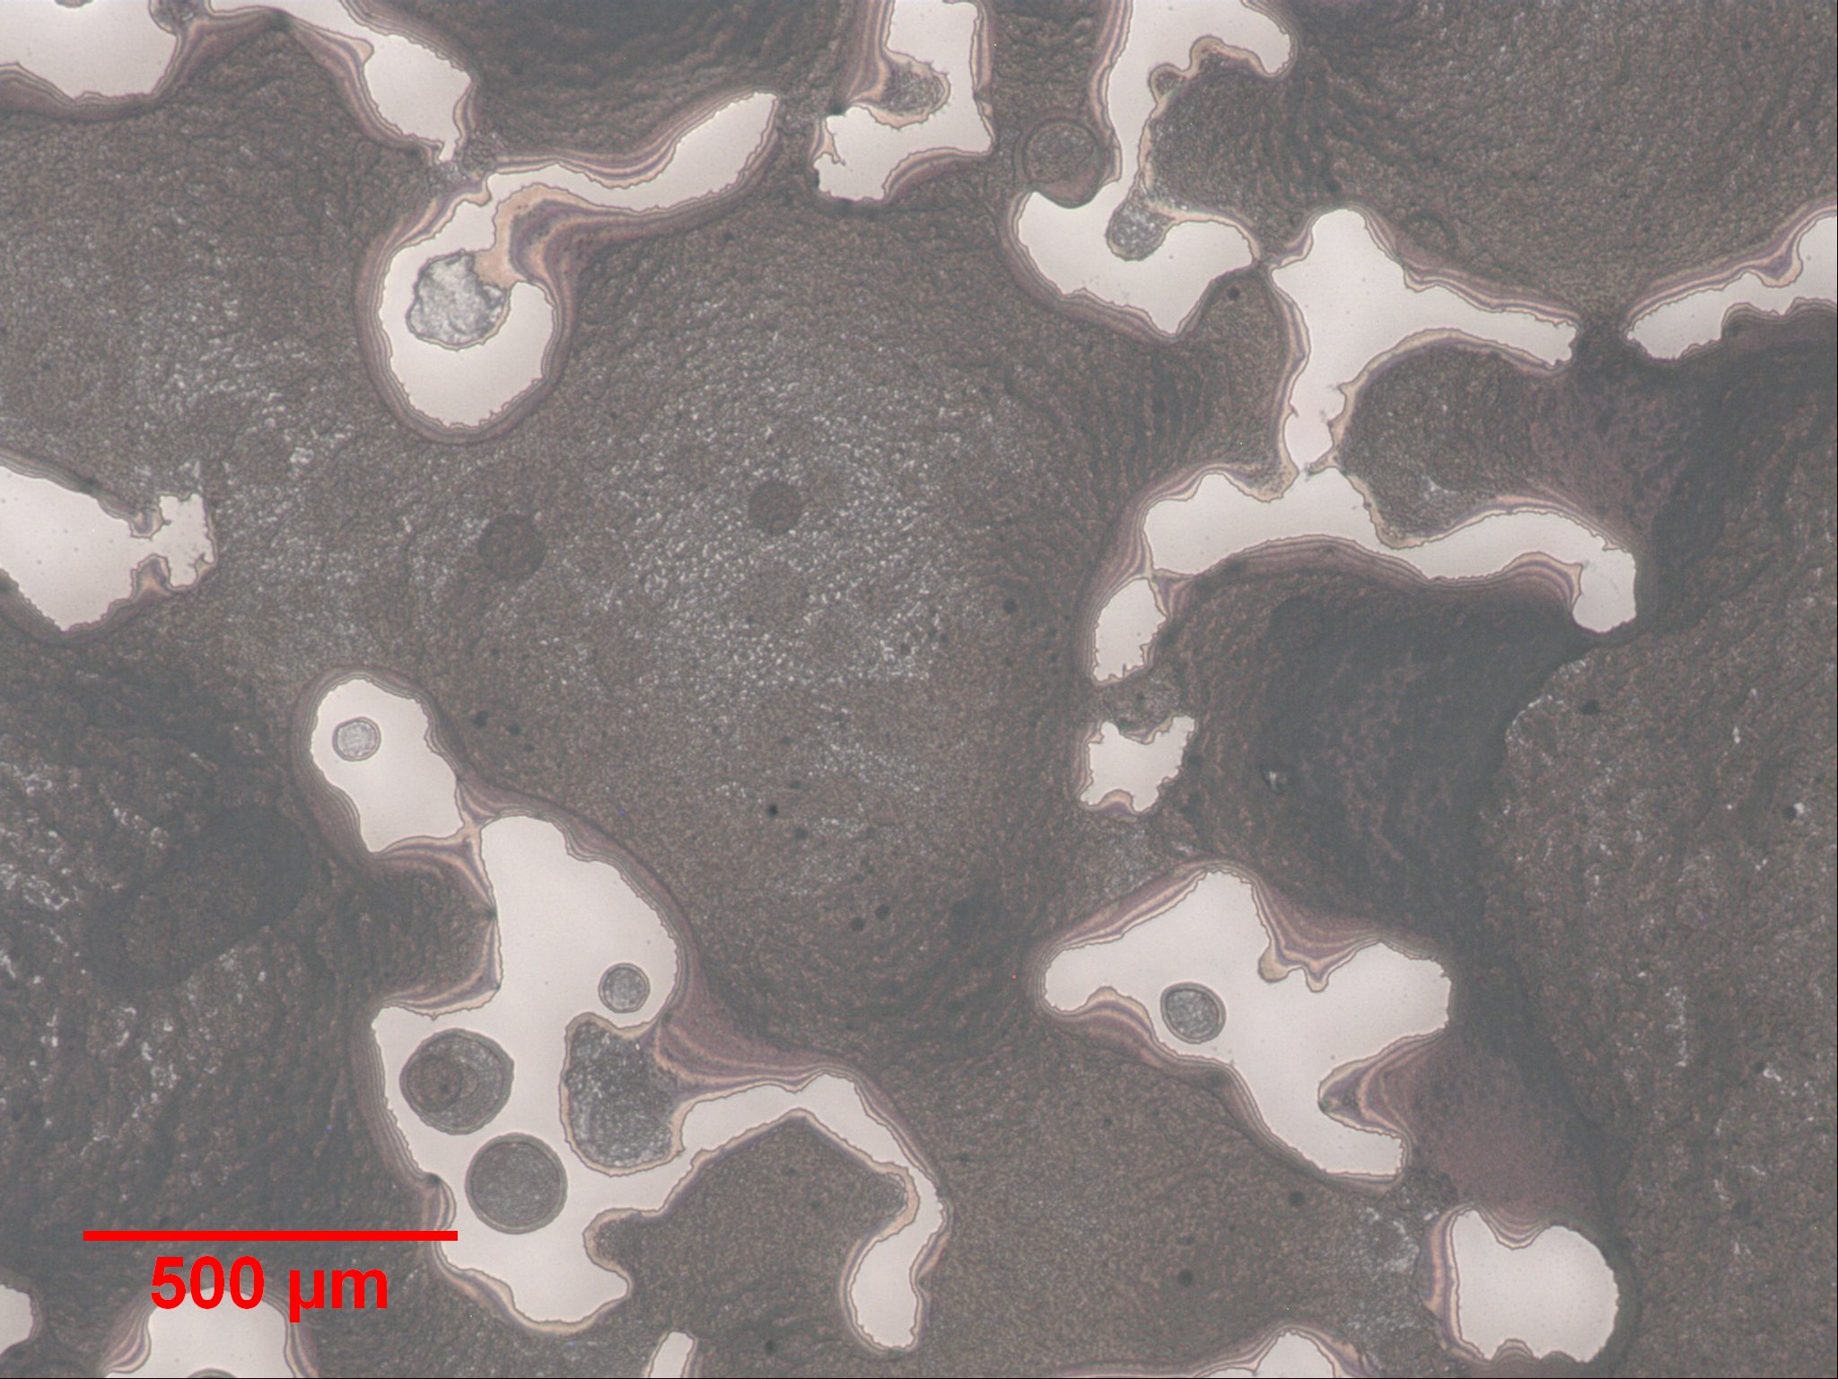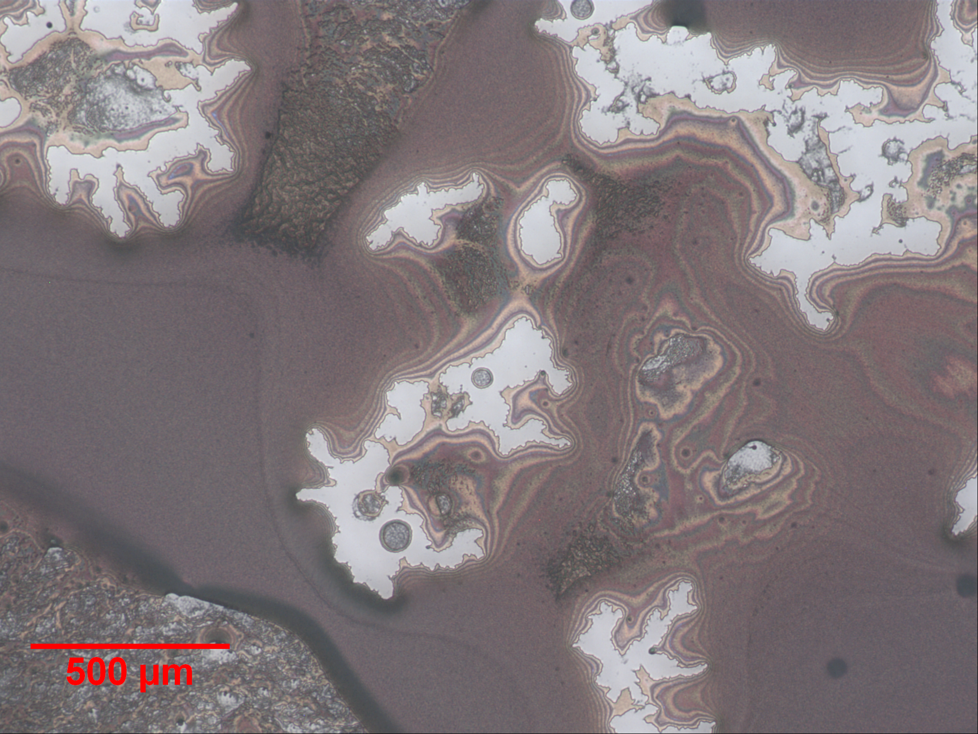
Figure 6. Microcope images of the printed slides. The leftmost image is from the image F in Figure 5. The rightmost image is from image B in Figure 5.
Initial Dip Coat
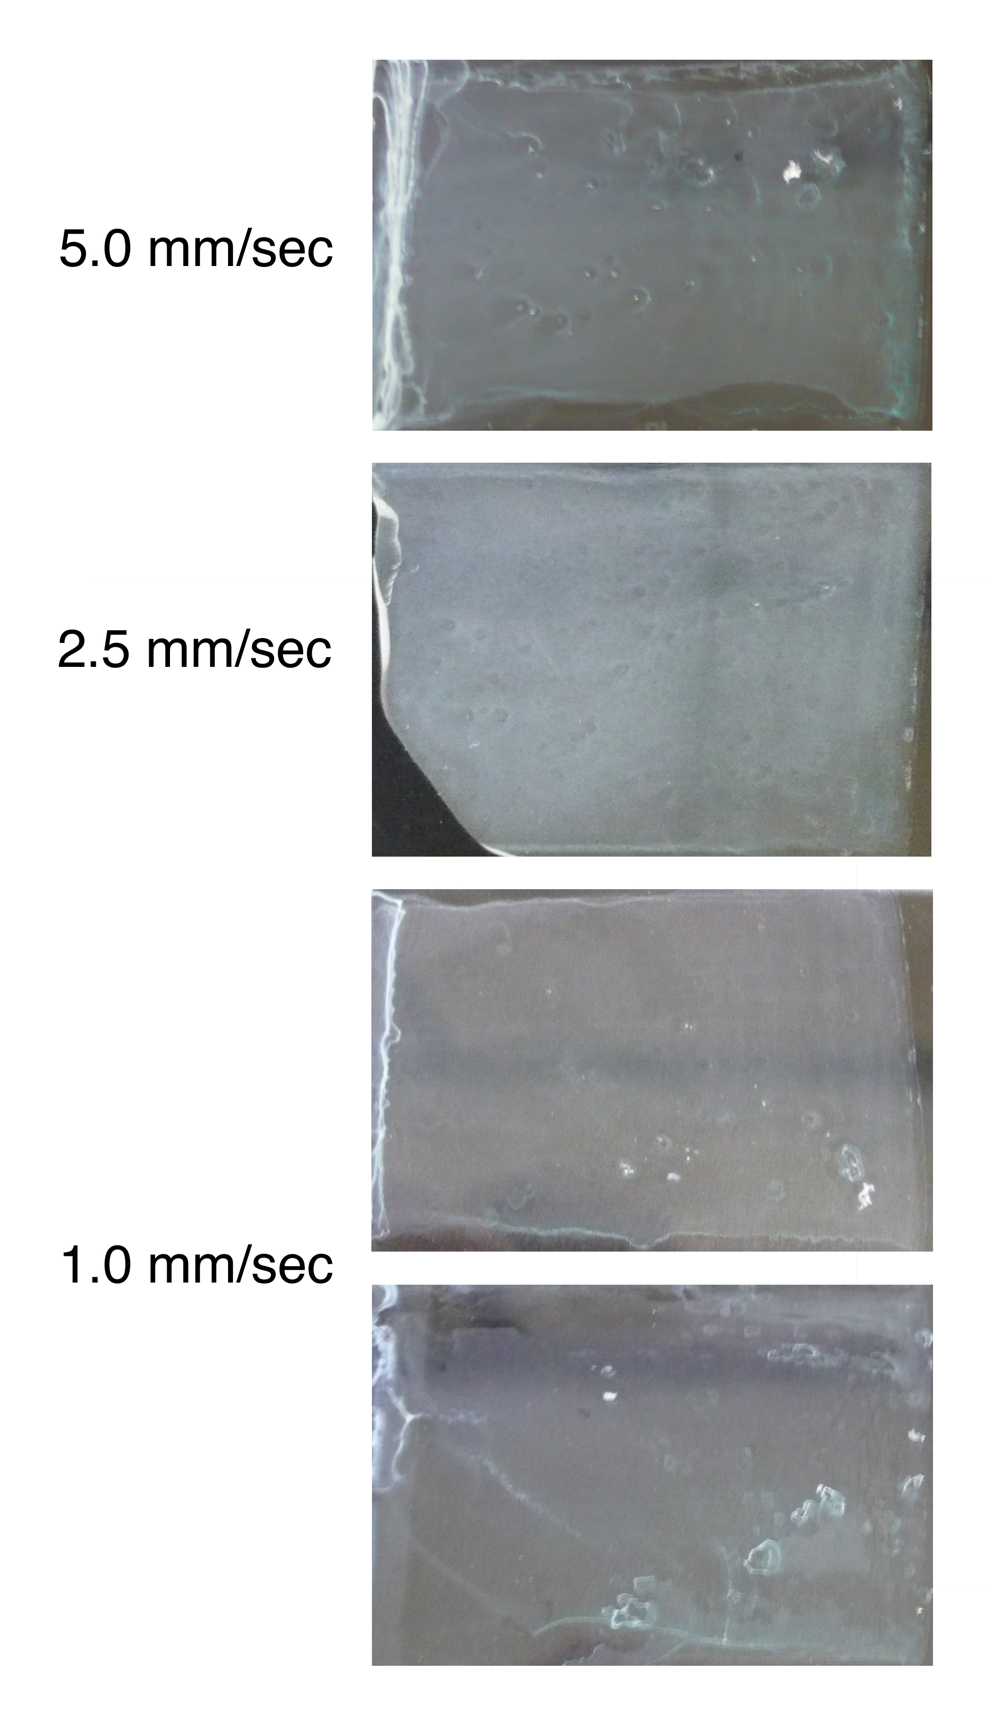
Figure 7. Photo images of the dip coated silica on glass slides.
Between samples the withdrawal speed was varied with the exception of the bottommost image that is also at 1.0 mm/sec, but the drying conditions were varied and the dry process was much slower. The sample with 2.5 mm/sec withdrawal speed chipped after the dip coating process and that chipped portion can be seen in the figure.

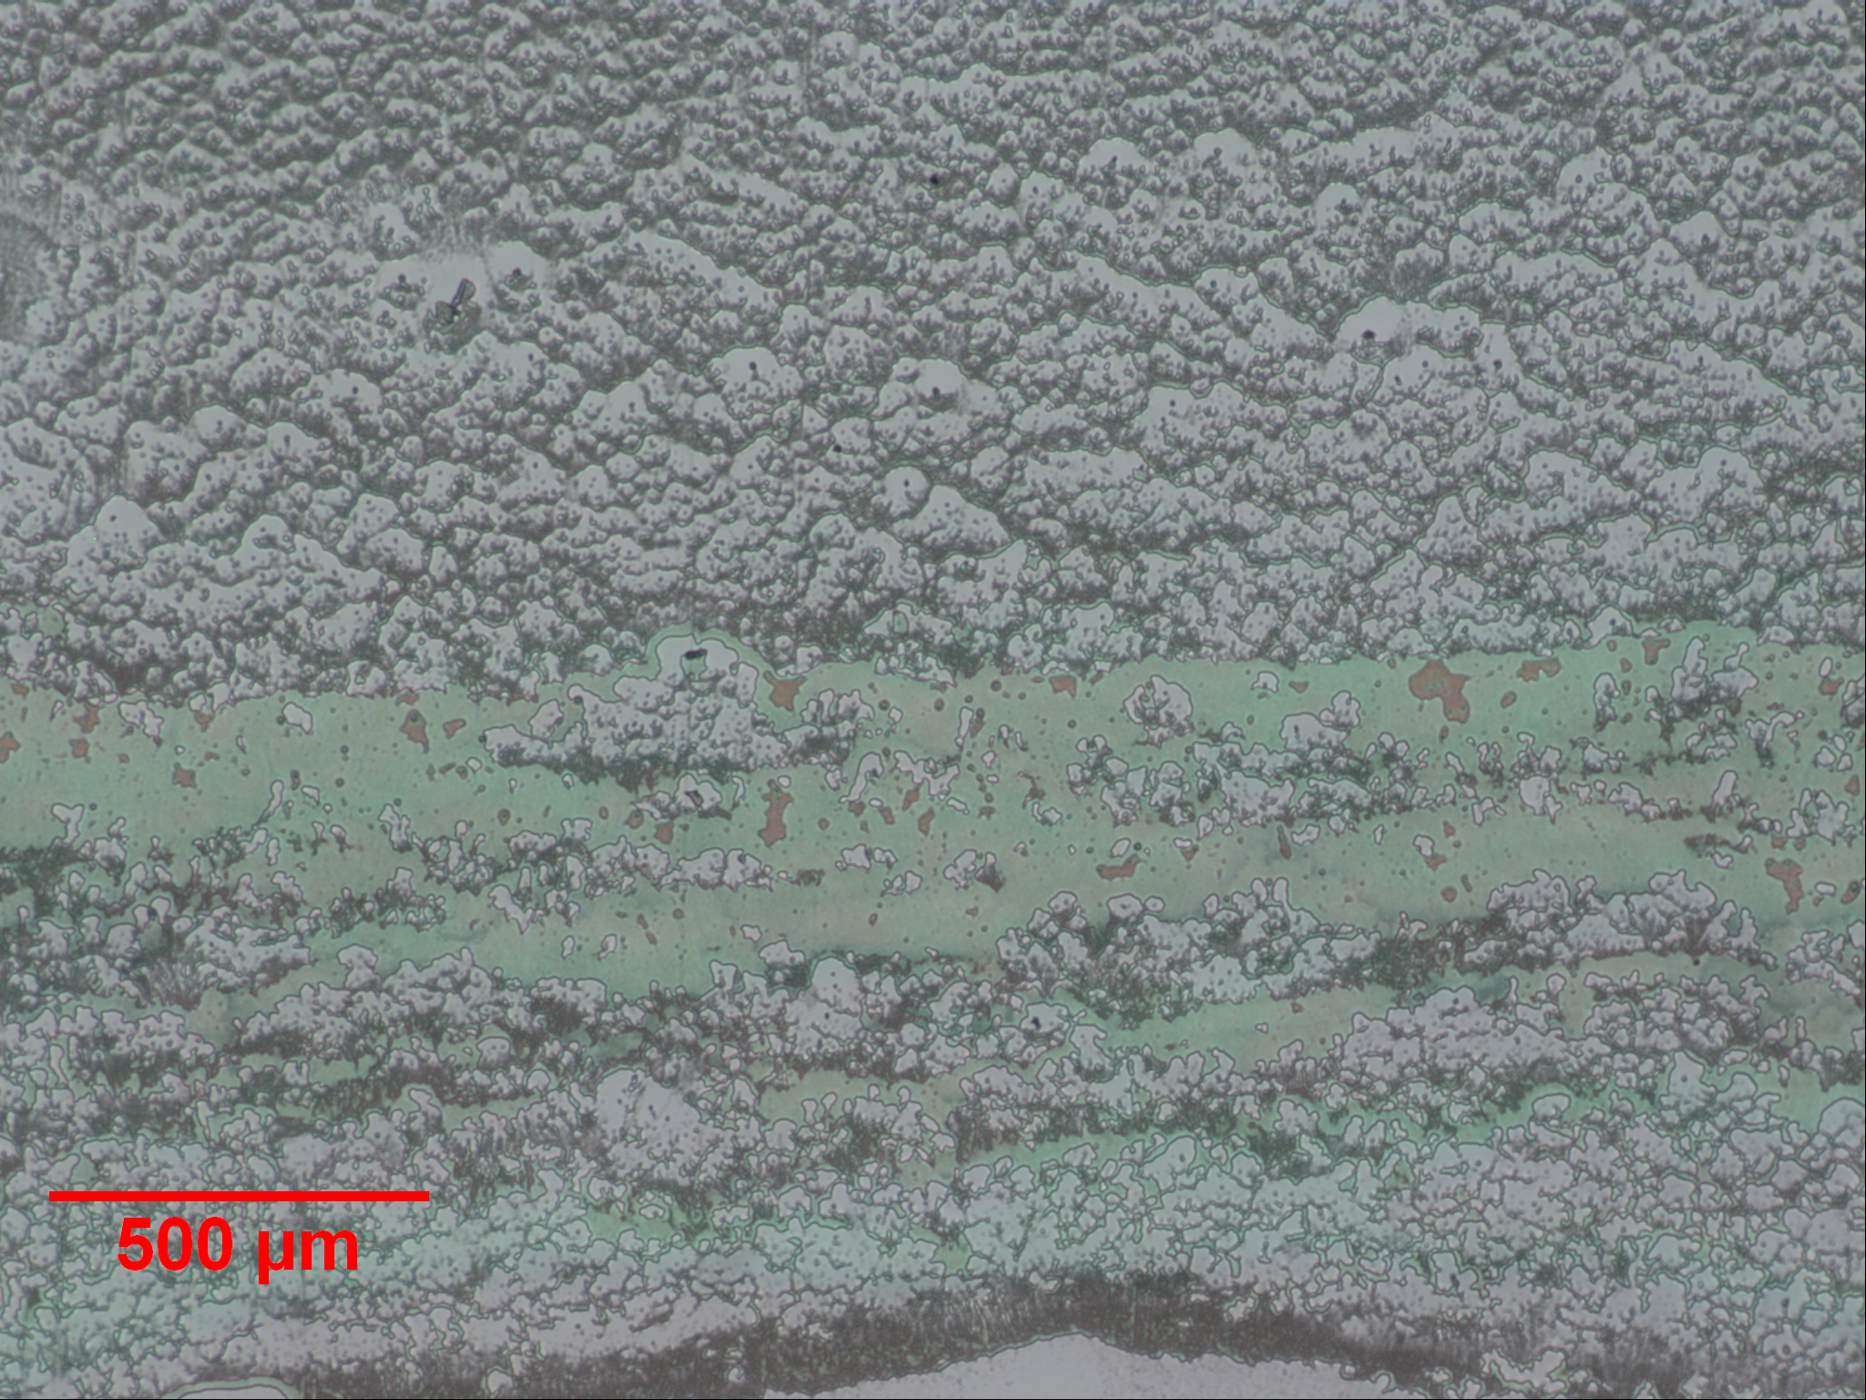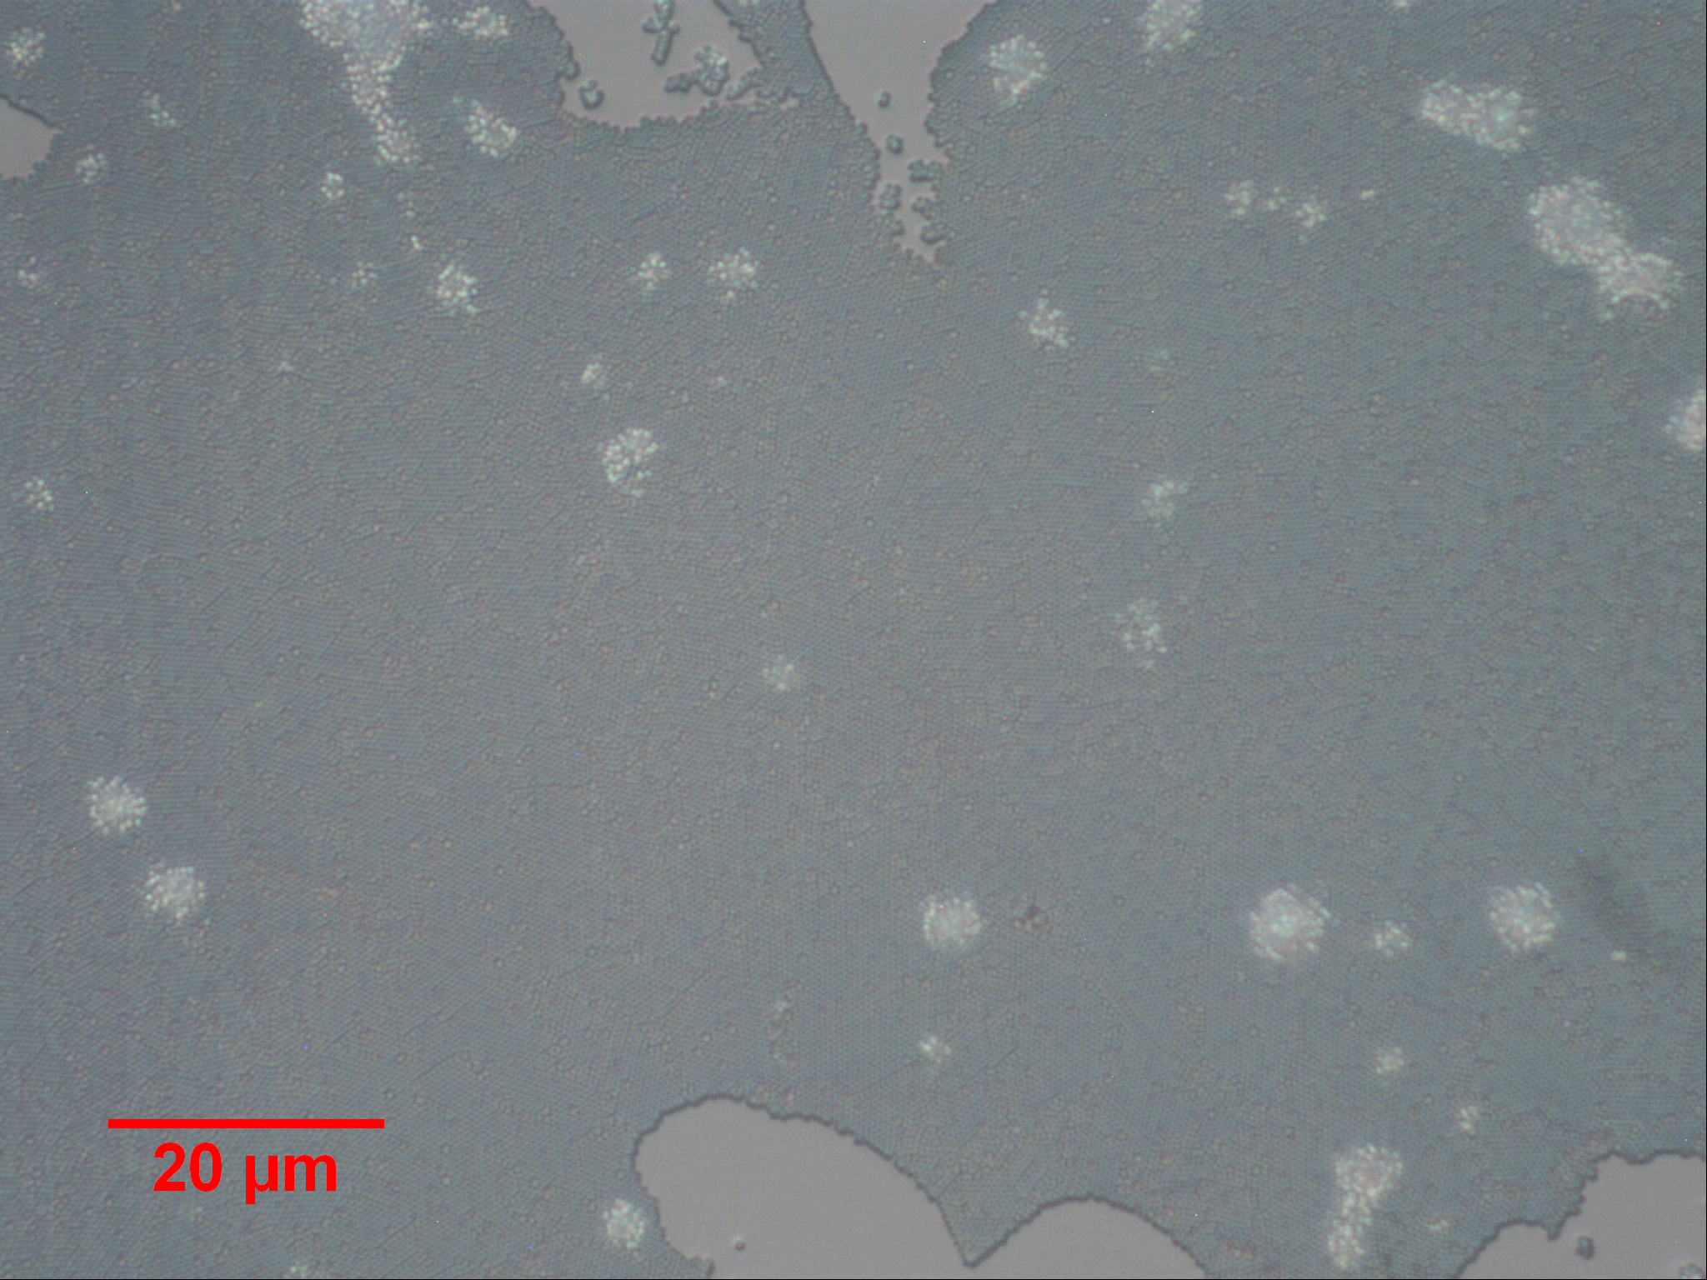
Figure 8. Microscope images of the dip coated samples.
The above images are from the same general area of the 2.5 mm/sec slide shown above of Figure 7 What is shown under the higher magnifications is located in the sea-foam green region of the larger image to the left. This region occurs at the edges of the dip coat’s coverage. In the photo image in Figure 7 this region can be seen at the edges of the slide as line with similar coloration.
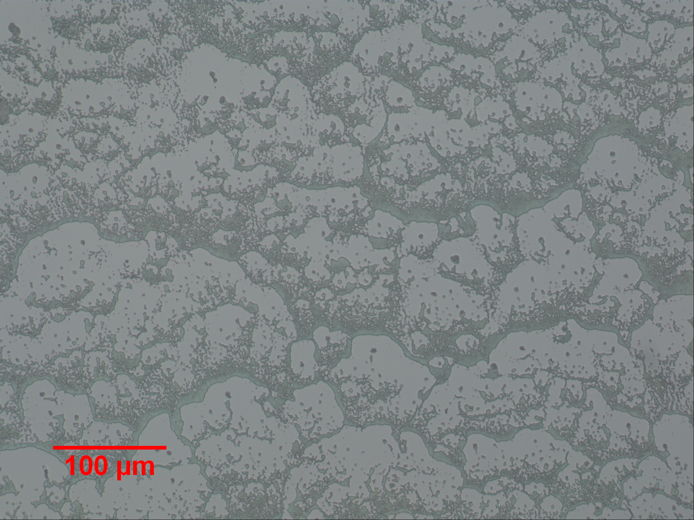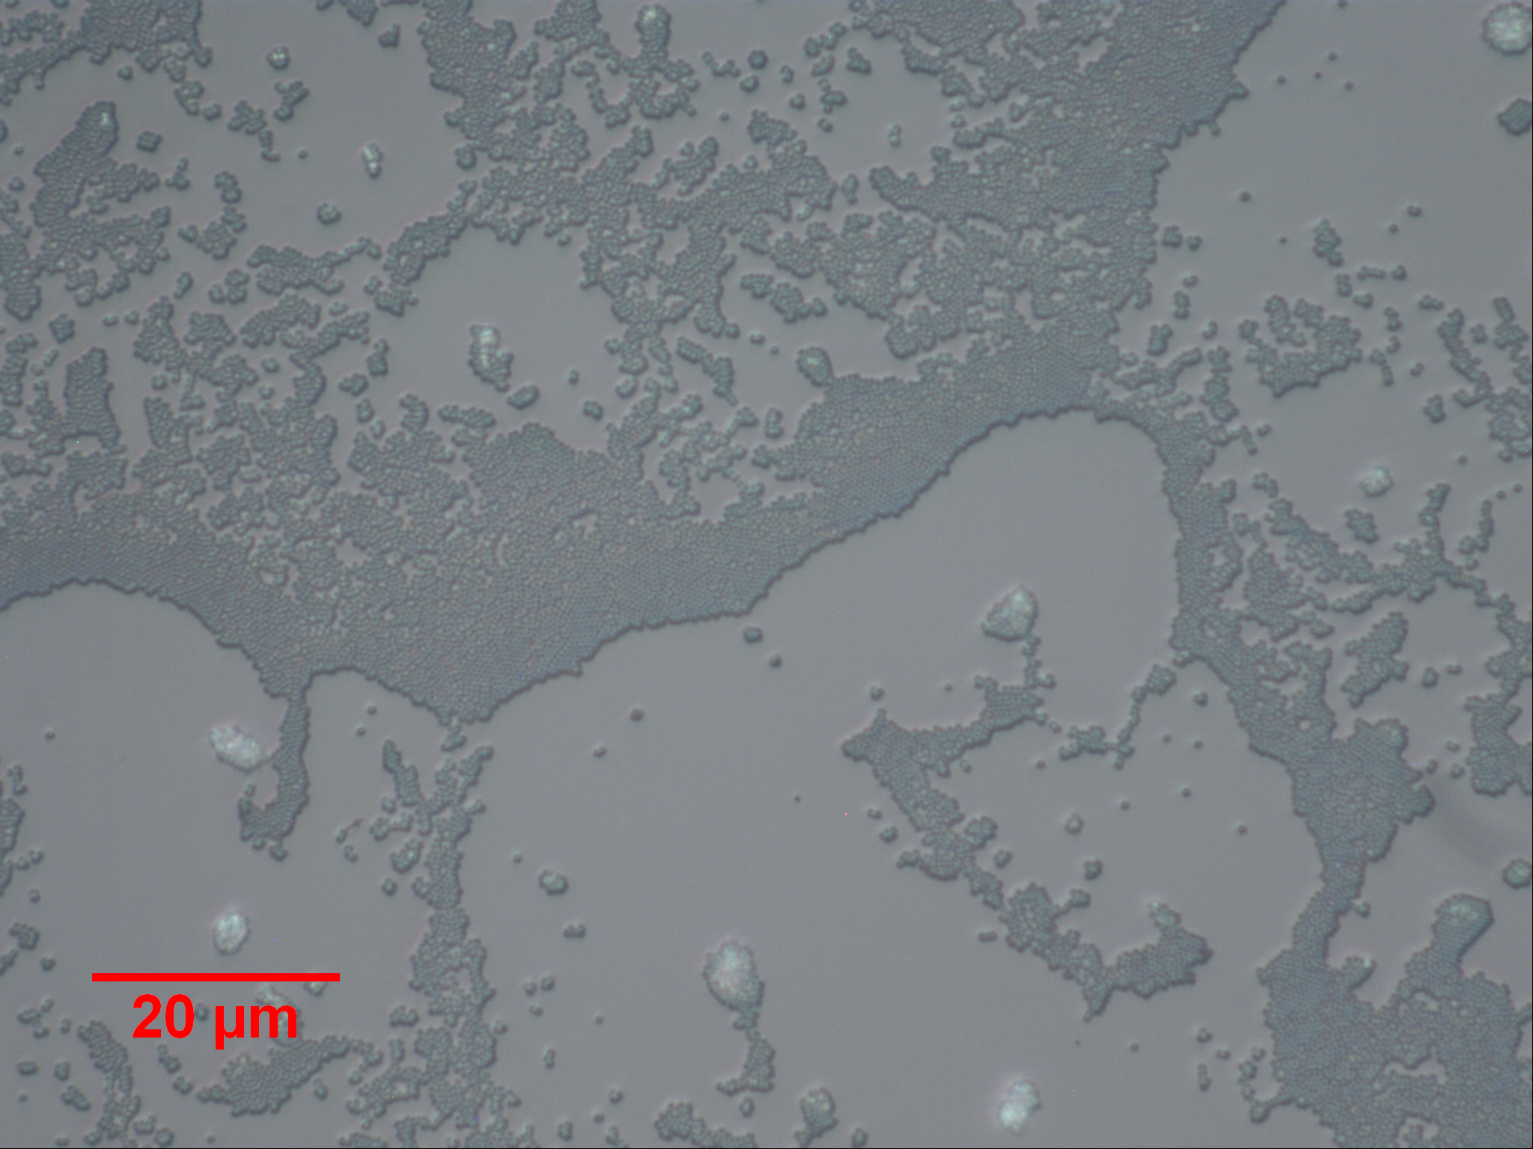
Figure 9. Addition microscope images of the dip coated samples.
The above images are from the same slide labeled B of Figure 7 (as in Figure 8). However, these images show a different region of the same slide. This region is more central on the slide; the left image shows a similar patterning to the top part of the leftmost image in Figure 8, but at an increased magnification.

Mixed Solvent Dip Coating
For mixed solvent solutions, dip coating was performed first because, under the experimental conditions, the dip coating process consumes far less solvent than direct-write printing, but requires a substantial reservoir of liquid in which to dip. Because of these factors, the dip coating was done first for all the solvents and the reservoir was cleaned between solvents.
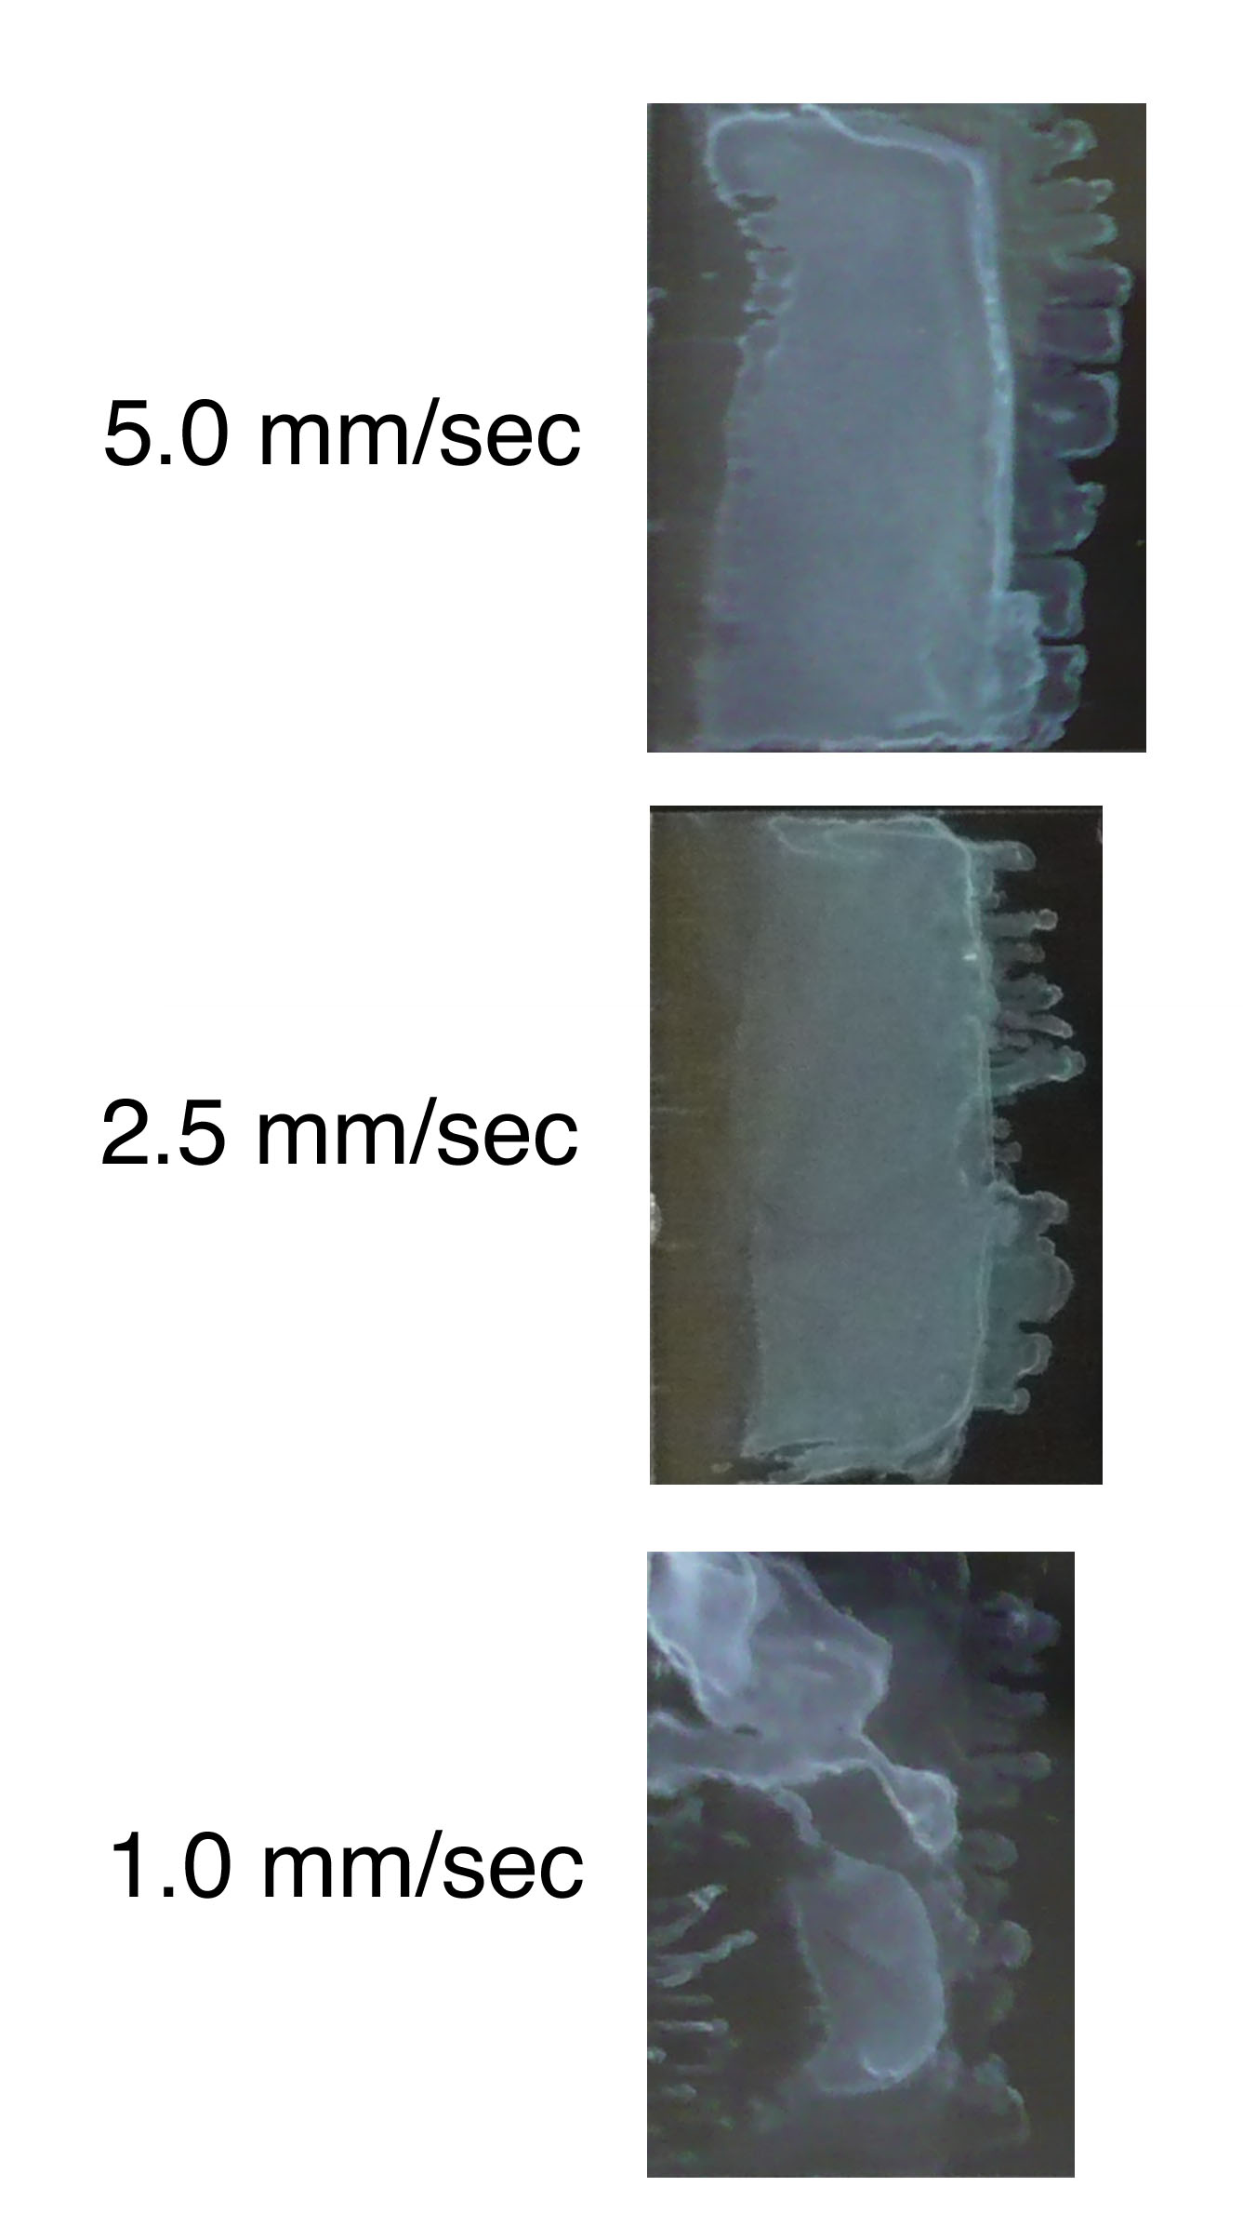
Figure 10. Images of the samples dip coated using the ethanol based solvent.
The withdrawal speeds here align with the speeds seen in the dip coated samples from the unmodified solution. Only the covered edge of the slide is shown in this image.
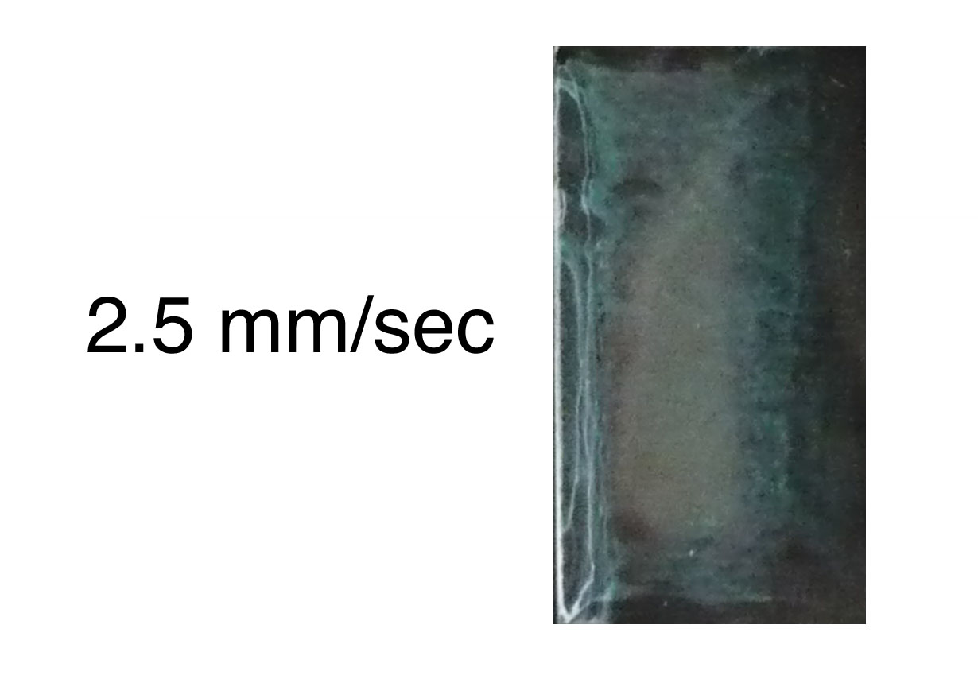
Figure 11. Image of the dip coated sample from the formamide solution
No images are shown for the sample using glycerol because the solvent did not evaporate from the slide after dip coating. For this same reason, printing using the glycerol solvent was not pursued and no images using the glycerol solvent are included in this report.

Direct-Write Ethanol
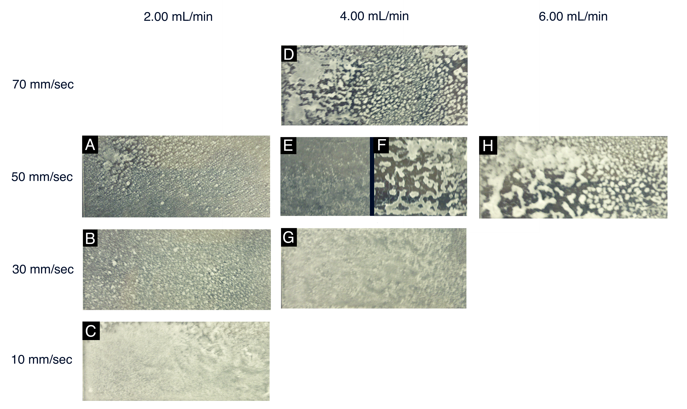
Figure 12. Photo images of the direct-write printing of 50 vol% ethanol colloidal solution.
There are two samples for the 50 mm/sec and 4.00 mL/min, shown in the figure as E and F. Half each sample is shown above, placed side-by-side with a black line separating the two.
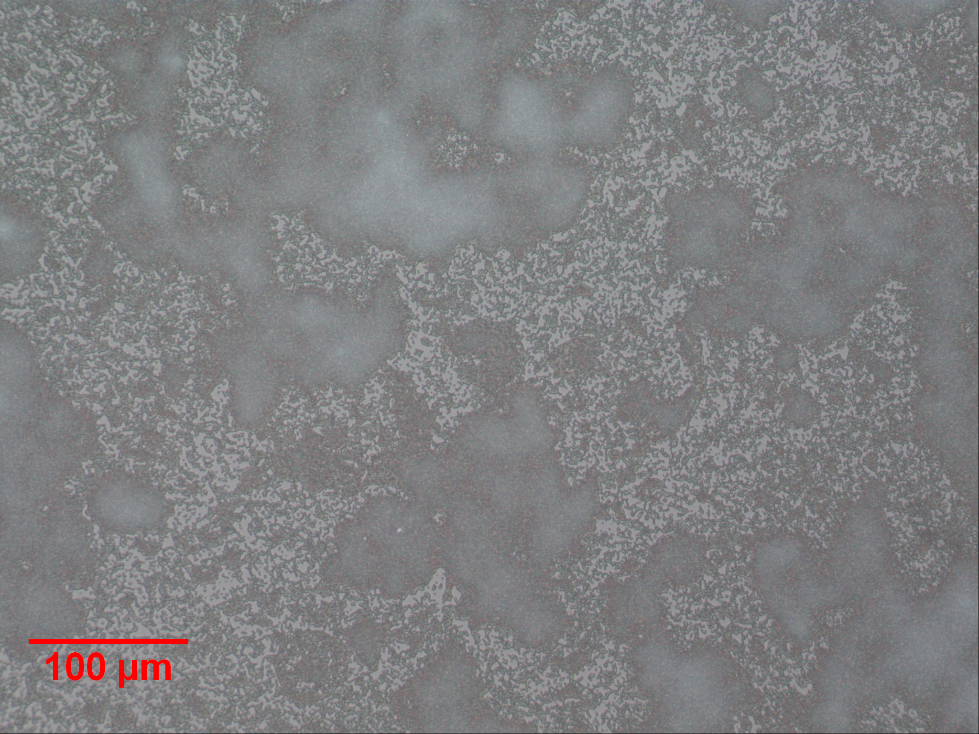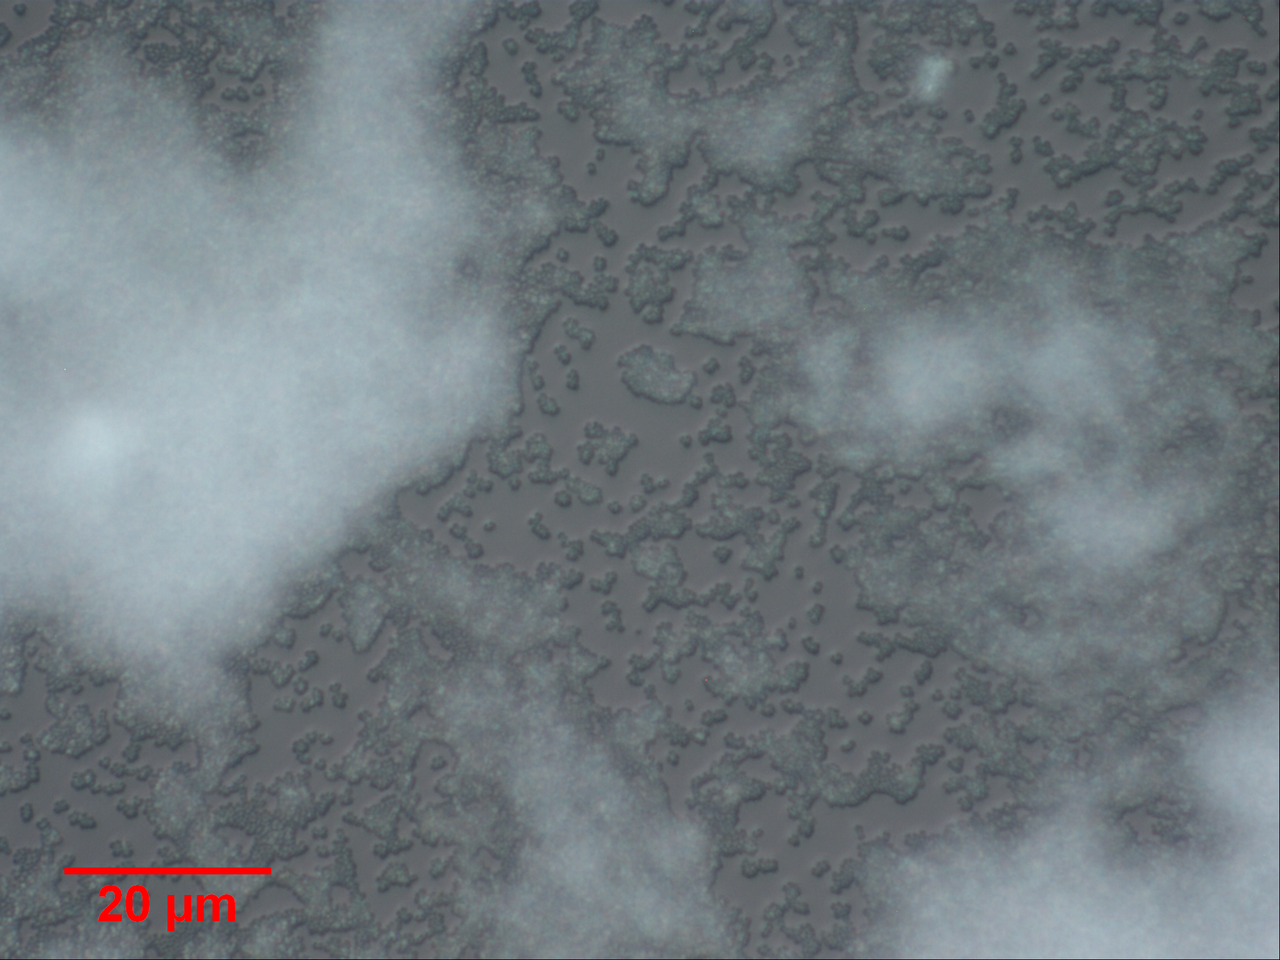
Figure 13. Microscope images of the direct-write printing with 50 vol% ethanol. The images shown here are from the slide labeled C of Figure 12.

Direct-Write Formamide
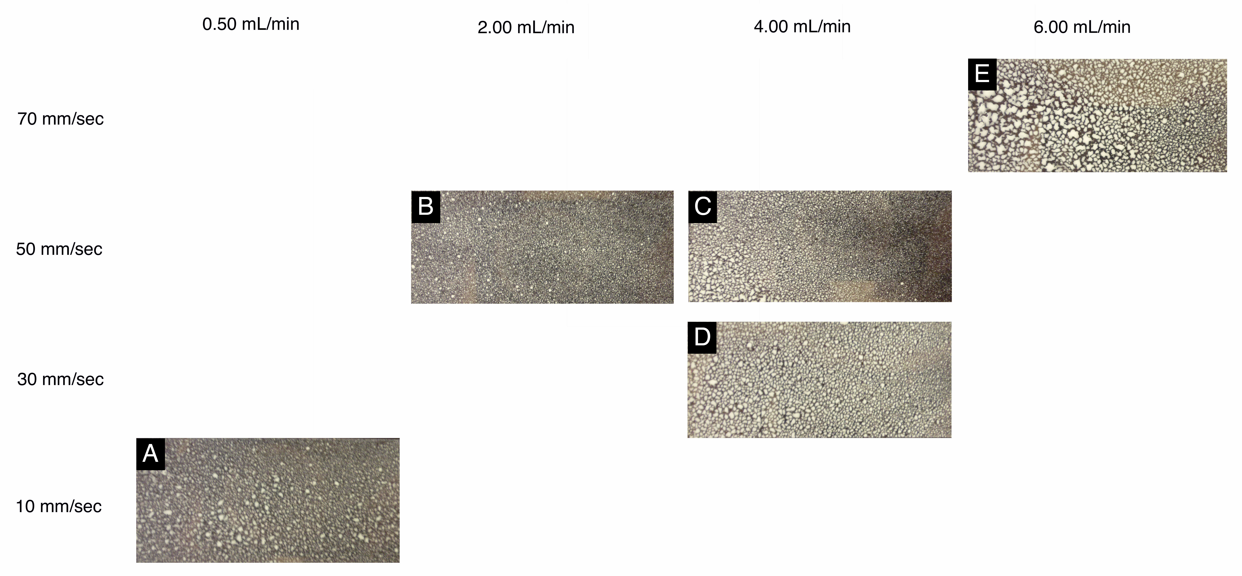
Figure 14. Photo images of the direct-write printing of 50 vol% formamide colloidal solutions.
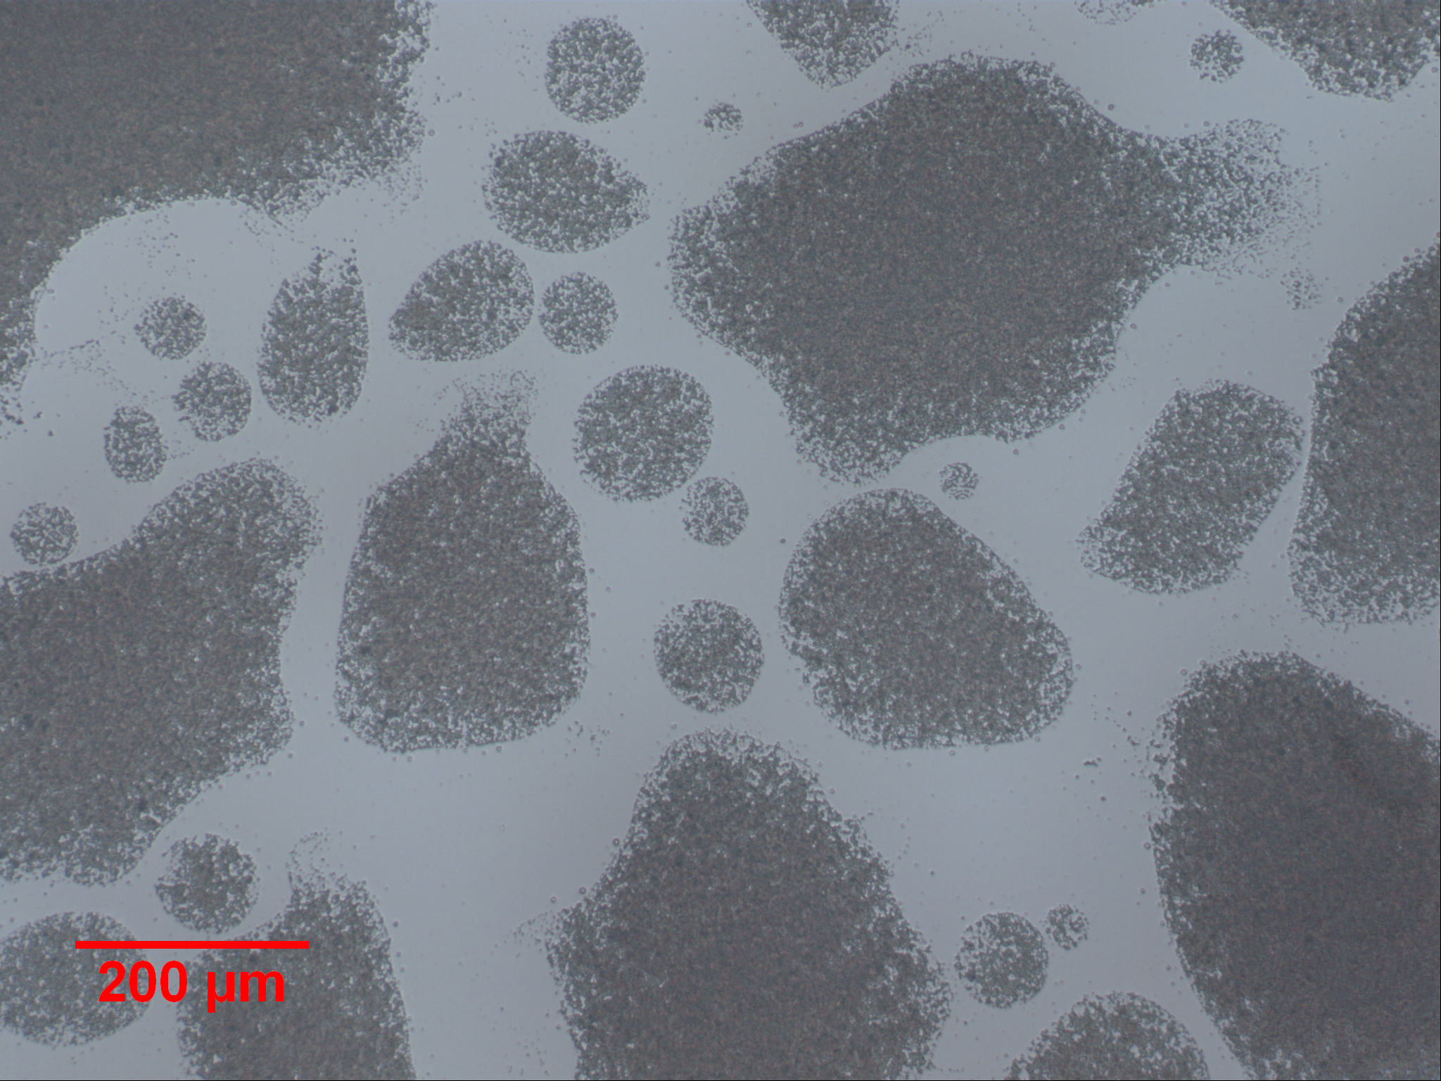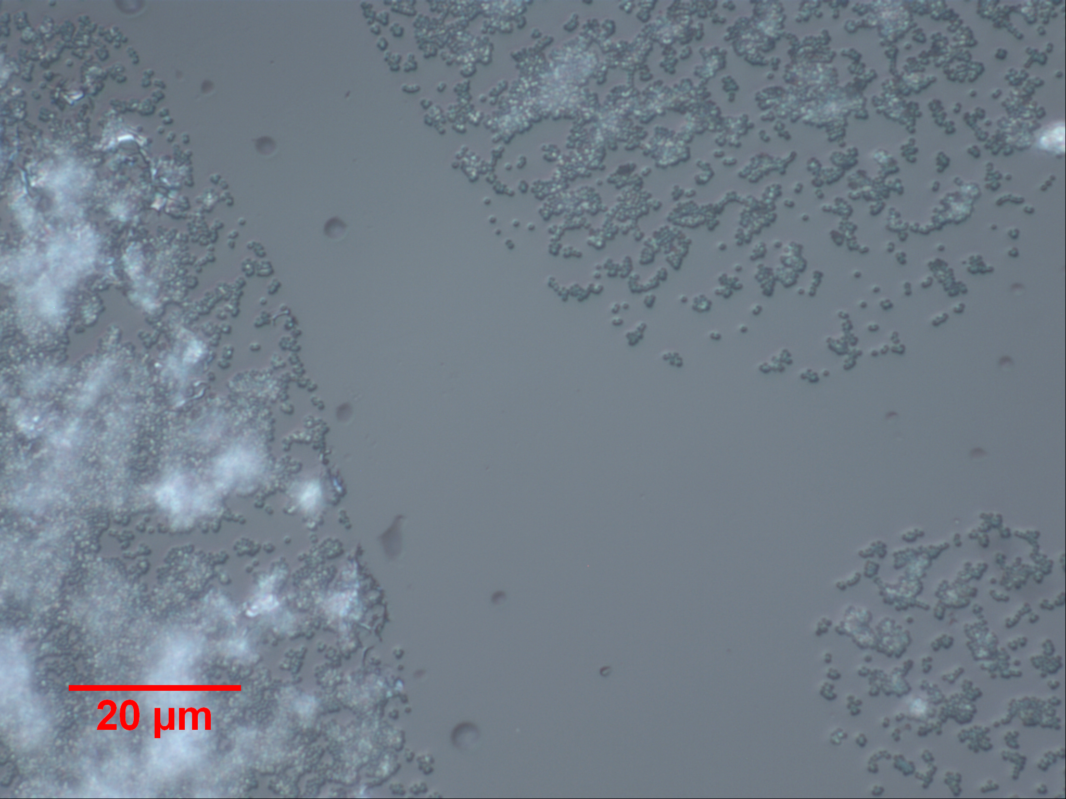
Figure 15. Microscope images of the direct-write printing with 50 vol% formamide. These images correspond to the slide labeled C in Figure 14.

Contact Angle
Table 1. Mean contact angle with the margin of error calculated at a single standard deviation.
Sample | Contact Angle (Degrees)
Unmodified Silica on glass | 21.7 ± 3.0
Unmodified Silica on Kapton | 51.6 ± 0.2
Unmodified Silica on silicon | 65.9 ± 3.1
Ethanol Solution on glass | 11.7 ± 1.9
Formamide Solution on glass | n/a

No values are reported for the formamide solution because the extensive wetting caused the angles to be too small to be measured using this instrument.

Surface Tension
Table 2. Average surface tension measurements with margin of error based on a single deviation.
Sample | Surface Tension, γ (nN m⁻¹)
Distlled water | 76.3 ± 0.4
Unmodified silica solution | 67.5 ± 5.6

The calculations of the software to determine γ require density information about the sample for calculations. The values used treat the silica solution as water, for that reason the values of distilled water are listed to give a basis of comparison.

Discussion
Initial printing on Kapton® and glass slides show a relatively low amount of close packing and uneven coverage. Well-ordered regions are only seen at the edges of the ring-like patterns seen in the depositions. These initial prints with the unmodified solution established some of the properties of the colloidal solution, including the appearance of the “coffee-ring” effect—so named for the dark edge seen in coffee spills. This effect occurs in suspensions of solid particles in a solution; as a drop of this suspension dries, the solvent at the edges evaporates faster than the solvent in the interior. Solution from the center flows to the edges by this difference in evaporation rates. This flow causes the buildup of solid along an outer ring as the solvent in the fresh solution evaporates at the edges.² Examples of the coffee-ring effect can best be seen in image F of Figure 5 as brighter, opaque white edges of silica in the otherwise cloudy deposition. The coffee-ring effect is not seen in the printed samples of either modified solution. The coffee-ring effect can be mostly in the samples that printing used the unmodified solution. The solutions printed used the mixed solvents show a reduced occurrence of this effect in line with methods used by other researchers to reduce this effect.¹⁴
An apparent difference in these samples shown in by printing and those of dip coating is the coloring. Figure 7 shows the first traces of green coloration instead of the milky white color of the bulk nanoparticle solution. By examination of these areas under the optical microscope, it can be seen in these areas that they show the largest regions of self-assembly into close-packed regions. By optical microscopy monolayer coverage is difficult to determine; however, based on the light penetration there are strong indications that these are regions have monolayer or bilayer coverage. The slides overall, under the optical microscope, show sparse coverage. By far, the best coverage achieved was by dip coating and can be seen in the unmodified sample withdrawn at a speed of 2.5 mm/sec.
The regions that show the best monolayer coverage appear iridescent green to the naked eye, whereas the areas that have more material deposited appear cloudy to opaque white. This observation may prove to be highly useful in quickly determining print quality. The silica nanospheres that were printed average approximately 500 nm, this size aligns with blue-green wavelengths in the light spectrum. More investigation needs to be done in order to prove this relationship. This light scattering effect is promising in terms of establishing a preliminary evaluation the coating quality with out the aid of a microscope.
The glycerol sample proved to be less than ideal for use in dip coating, because the sample was unable to evaporate under ambient conditions. Because of this a 50 vol% solution of glycerol is inappropriate for the purposes of this research. A different ratio of glycerol to water may be further investigated for use. Glycerol is much safer to work with than the other high boiling point solvent that was investigated (formamide) and the increased viscosity of the solution may prove to be desirable. In the current 50 vol% solutions, the glycerol solution has visually less settling of the particles over an extended period of time compared to the other solvent compositions. This occurrence most likely stems from the high viscosity in the solution, and tests could be performed on the solutions to investigate this occurrence. For these reasons, future investigators may reevaluate glycerol solutions.
Results of the contact angle measurements show that the mixed solvents exhibit a decrease in contact angle on glass substrates compared to the original unmodified solution. The formamide solution has a more dramatic decrease than the ethanol, to the point that it wets the galss substrate completely. The unmodified solution on both silicon and Kapton® show a higher contact angle than that on glass. This difference helps account for the differences in print patterning on the surface of the Kapton® samples versus the continued work on glass. The surface tension values of water and the colloid solution were measured. What can be seen from these values is that surface tension of the colloid solution appears be decreased from that of distilled water.

Conclusions
The goal of this research was to obtain a uniform, highly-ordered monolayer of nanoparticles by direct-write printing these particles. This was investigated using the Sono-Tek ExactaCoat and Impact EDGE™ nozzle, which atomizes the nanoparticles from the ultrasonic nozzle and disperses solution by air jet into a fan-shaped spray pattern. The printing is achieved in a single pass from the ExactaCoat with spray established before reaching the slide itself for the highest quality coating. The first set of prints used the original nanoparticle solution with no modifications on glass slides. As a point of comparison glass slides were also dip coated into the same original nanoparticle solution.
In attempts to have better slide coverage and for ordering of the nanoparticles to be more in line with what can be achieved by dip coating the solvent composition was modified. Solvents with different boiling points, but that are miscible with water were mixed with portions of the original solution to create new solutions. 50 vol% ethanol was used to create a solution that was lower boiling point the original and 50 vol% formamide was used to create a solution with a higher boiling point than the original solution. These two new solutions were dip coated and printed under similar conditions to the unmodified solution. These ratios can be further modified to adjust the total solvent properties as necessary for refine the results.
It was found that the areas of best single layer coverage appear with slight green coloration that is believed to result from the diameter of the nanoparticles correlation to the same value for the wavelengths of green. The end goal of the research was not achieve but work has laid the foundation for direct-write printing of self assembled nanoparticle monolayers. But the true challenge in printing these particles is the balance of having a single particle layer but still obtaining complete coverage on the substrate.

Recommendations and Future Work
A refinement of mixed solvent printing is needed in order to achieve a balance of uniform surface coverage and single layer thickness. Variables that can be further investigated are the nanoparticle density in solution, solvent proportions (this change may make glycerol a viable solvent), and further modification of the print parameter themselves. The most important recommendation in this regard is to have familiarity with the instrument being used for direct-write printing (the ExactaCoat ins this case). There are many variables involved in the print process and it is important to know the capabilities and limitations of the instrument.
The prints this should be further investigated to evaluate the consistency problems and to determine if the cause that can be addressed. One hypothesis to explain this occurrence is that particle aggregation and settling is occurring while the solution is waiting in the ExactaCoat to be printed. This may also be dependant on the solvent properties of the solution. Apparent visually is that the 50 vol% glycerol solution holds the particles in solution far longer than the other solutions. The increased viscosity from the glycerol likely explains this observation. Adding to problems of reproducibility is the lab environment itself as it is not controlled in either temperature or humidity. In future studies this should be apparent as a factor if not monitored as another variable.
The trend of the green coloration as consequence of the nanoparticle sizing can be further investigated by dip coating particles whose mean size correlates to a different color in the visible spectrum and investigating the results for different colors. In depth inquiry into similar nanoparticle experiments may also yield useful references.

References
- Cai, Y.; Zhang Newby, B.-m. Marangoni Flow-Induced Self-Assembly of Hexagonal and Stripelike Nanoparticle Patterns. J. Am. Chem. Soc. [Online] 2008. 130(19), 6076-6077. http://pubs.acs.org/doi/full/10.1021/ja801438u
- Deegan, R. D.; Bakajin, O.; Dupont, T. F.; Huber, G.; Nagel, S. R.;. Witten, T. A (1997). Capillary flow as the cause of ring stains from dried liquid drops. Nature. 1997. 389(6653), 827–829.
- Dimitrov, A. S.; Nagayama, N. Continuous convective assembling of fine particles into two-dimensional arrays on solid surfaces. Langmuir. [Online] 1996. 12(5), 1303-1311. http://pubs.acs.org/doi/abs/10.1021/la9502251
- Grzelczak, M.; Vermant, J.; Furst, E. M.; Liz-Marzán, L. M. Directed Self-Assembly of Nanoparticles. ACS Nano. [Online] 2010. 4(7), 3591-3605. http://pubs.acs.org/doi/pdfplus/10.1021/nn100869j
- Impact EDGE Air Shaping System, Sono-Tek Corporation. http://www.sono-tek.com/impact (accessed Aug. 3, 2012).
- Járai-Szabó, F.; Aştilean, S.; Néda, Z. Understanding self-assembled nanosphere patterns. Chem. Phys. Lett. [Online] 2005. 408(4-6), 241-246. http://arxiv.org/pdf/cond-mat/ 0502371v2.pdf
- Jie-Ren, L.; Garno, J. C. Elucidating the role of surface hydrolysis in preparing organosilane nanostructures via particle lithography. Nano Lett. [Online] 2008. 8(7), 1916-1922. http://pubs.acs.org/doi/abs/10.1021/nl0806062
- Jie-Ren, L.; Nai-Ning, Y.; Gang-yu, L. Hierarchical micro- and nanoscale structures on surfaces produced using a one-step pattern transfer process. J. Phys. Chem. Lett. [Online] 2011. 2(4), 289-294. http://pubs.acs.org/doi/abs/10.1021/jz101609a
- Kralchevsky, P. A.; Denkov, N. D. Capillary forces and structuring in layers of colloid particles. Curr. Opin. Colloid Interface Sci. [Online] 2001. 6, 383-401. http://dce.uni-sofia.bg/files/publications/2001/2001-03-PK.pdf
- Luminescent Solar Concentrators, South Dakota IGERT. http://sdigert.org/LuminescentSolarConc.html (accessed Aug. 3, 2012).
- Mahalingam, V.; Onclin, S.; Péter, M.; Ravoo, B. J.; Huskens, J.; Reinhoudt, D. N. Directed Self-Assembly of Functionalized Silica Nanoparticles on Molecular Printboards Through Multivalent Supramolecular Interactions. Langmuir. [Online] 2004. 20(26), 11756-11762. http://pubs.acs.org/doi/pdfplus/10.1021/la047982w
- Mullen, T. J.; Zhang, M.; Feng, W.; El-khouri, R. J.; Sun, L.; Yan, C.; Patten, T. E.; Liu, G. Fabrication and characterization of rare-earth-doped nanostructures on surfaces. ACS Nano. [Online] 2011. 5(8), 6539-6545. http://pubs.acs.org/doi/full/10.1021/nn201910f
- Park, J.; Moon, J. Control of colloidal particle deposit patterns within picoliter droplets ejected by ink-jet printers. Langmuir. [Online] 2006. 22(8), 3506-3513. http://pubs.acs.org/doi/abs/10.1021/la053450j
- Shen, X.; Ho, C.; Wong. T. Minimal Size of Coffee Ring Structure. J. Phys. Chem. B. [Online] 2010. 114(16), 5269-5274. http://pubs.acs.org/doi/abs/10.1021/jp912190v
- Stöber, W.; Fink, A.; Bohn, E. Controlled growth of monodisperse silica sphere in the micron size range. J. Colloid Interface Sci. 1968. 26(1), 62-69.
- Wang, Y.; Chen, L.; Yang, H.; Guo, Q.; Zhou, W.; Tao, M. Large-Area Self Assembled Monolayers of Silica Microspheres Formed by Dip Coating. Mater. Sci-Pol. [Online] 2010. 28, 467-478. http://www.dtic.mil/cgi-bin/GetTRDoc?AD=ADA526674

Acknowledgments
In love and memory of Timothy Killian, who was one of my closest friends and the best man I’ve ever known. His life was ended tragically early on July 4, 2012. May he rest in peace.
The funding for this research comes from the National Science Foundation. This research simply could not have been accomplished without the support of advisors Dr. Jon Kellar and Dr. William Cross, and the collaborative efforts of graduate student, Mr. Kelsey Fitzgerald. Thank you to the REU group, especially to Dr. Michael West and Dr. Alfred Boysen for what they contribute to making this program spectacular. Also, thanks to Mr. James Randle director of the Direct-Write Print Lab for his efforts and training. Thank you especially to everyone who has supported me in this trying time and to anyone that may I have inadvertently missed.

